

ESESG Sustainability Charter: Briefing note

**Why was the Charter was developed?**

The ESESG Sustainability Charter has been developed by members from multiple Fire & Rescue Services and Police Forces to:

* Drive the collective action needed to address the challenges of climate change
* Assist all Emergency Services with their sustainability journey, whatever their starting point
* Include the latest developments of the global sustainability agenda
* Adopt the three principles of sustainability for inclusion in everyday operations

**Explaining the sustainability journey**

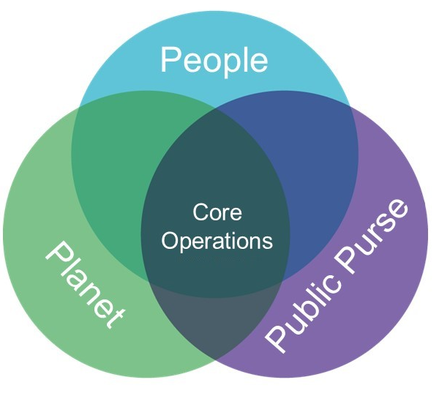Wherever your organisation is on the sustainability journey you can incorporate the three sustainability principles adopted in the charter into core operations.

Social, economic and environmental aspects are for all Emergency Services to consider and commit to, and the Charter offers a solid foundation built on best practice and current topical issues, to ensure we are working to achieve common goals to embed sustainability into our activities processes and services.

**Who should be aware of the Charter within your organisation?**

The Charter is designed as a high-level strategic document, to be signed off by senior leaders such as Chief Constables and Fire Chiefs with a view to each organisation specifying how they are contributing to the overall Charter; referring to organisation specific strategies and programmes which are already in place.

**The benefits of signing the charter**

* Demonstrate collaboration with other emergency services through the adoption of common sustainability goals and aspirations
* Showcase our collective commitment to act responsibly and contribute positively to sustainability and share with the communities we serve.
* Provide a sustainability working structure which can be adopted by all emergency services whatever point of their sustainability journey.

**Sustainability – the ongoing journey**

The Emergency Services Sustainability Charter shall be managed by ESESG and will be reviewed every three years. An annual update of group members sustainability journeys will be communicated every October, highlighting sustainability best practices employed and providing useful examples of sustainability projects.